**Ideation Phase**

**Brainstorm & Idea Prioritization Template**

|  |  |
| --- | --- |
| Date | 26-6- 2025 |
| Team ID | LTVIP2025TMID59476 |
| Project Name | Shopsmart:Your Digital Grocery App |
| Maximum Marks | 4 Marks |

**Brainstorm & Idea Prioritization Template:**

**ShopSmart – Your Digital Grocery App** is an innovative digital grocery platform designed to seamlessly connect customers with local grocery stores. It focuses on transforming the grocery shopping experience through an intuitive interface, smart search and filtering, real-time inventory updates, and secure order and delivery workflows.

This brainstorming session template fosters a free and collaborative space where all team members are encouraged to contribute unique, creative, and out-of-the-box ideas. The goal is to identify, group, and prioritize key features that enhance platform usability, reliability, and overall experience for both customers and vendors.

Use this document to capture your team’s imagination and transform raw ideas into structured, prioritized solutions that align with the mission of **ShopSmart**—**making grocery shopping smarter, faster, and more convenient for everyone.**

**Step-1: Team Gathering, Collaboration and Select the Problem Statement**

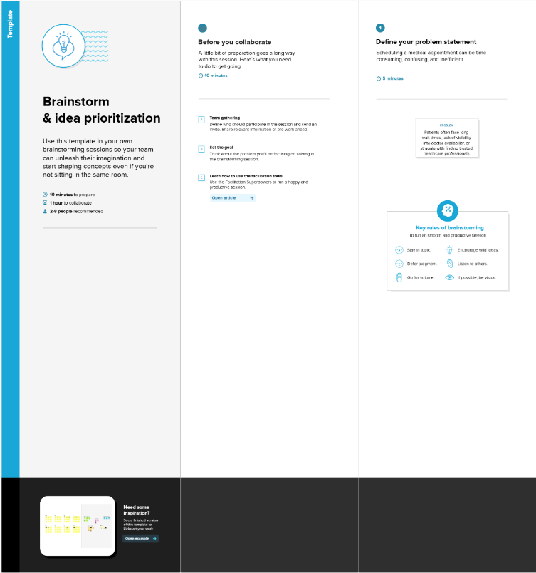

**Step-2: Brainstorm, Idea Listing and Grouping**

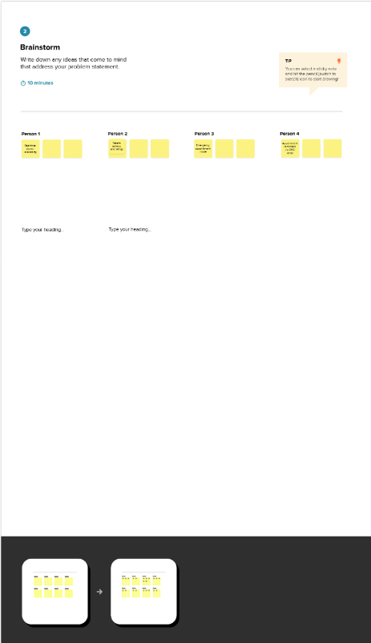

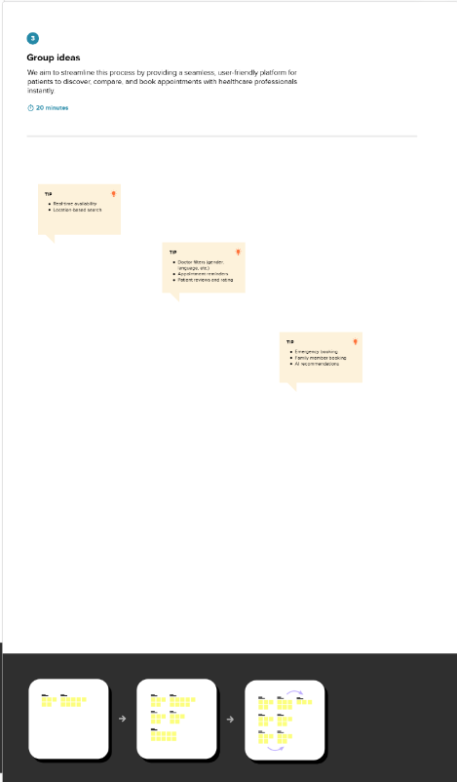

**Step-3: Idea Prioritization**

